SYNOPSIS

Food Waste Management System

Submitted by

Harsh Gupta
CET RANK 787
ROLL NO 02411104420

MCA (Master of Computer Application)

Banarsidas chandiwala Institute of Information and
Technology

ABSTARCT

This project is used to manage wastage foods in a useful way. Every day the people are wasting lots of foods. So we have to reduce that food wastage problem through online. If anyone have wastage foods they are entering their food quantity details and their address in that application and then the admin maintain the details of food donator.
The donator can create the account and whenever they are having wastage food they can login and give request to the admin. And the admin also maintain the buyer(orphanage,poor people,..) details too. After the admin view the donator request and give the alert message like time to come and collect the food.
And the admin collect foods from donator through their nearby agent then provide to nearest orphanages or poor people. After receiving the food from the agent by admin and give alert message to that donator. If the donator need any detail about the orphanage with helping thought they can give request to the admin and collect the orphanage details.
This project is food redistribution is an enormously successful social innovation that tackles food waste and food poverty. The user’s details are maintained confidential because it maintains a separate account for each user.

Existing System
In existing system if anyone have extra food because of any function or in their home it will be become waste because instantly there is no way to share with anyone if they are having lots of food. Even if they want to give that extra food to any orphanage or poor people they don’t have time or don’t have an idea about that
So that we have create a application for sponsor that extra food to poor people or nearby orphanage.
Proposed System
In proposed system we are reduce that food wastage using that application.
This project is food redistribution is an enormously successful social innovation that tackles food waste and food poverty. the admin collect foods from donator through their nearby agent then provide to nearest orphanages or poor people. After receiving the food from the agent by admin and give alert message to that donator through this way we can reduce food wastage problem.
Modules:
In this project consist of the different types of module.
The modules are:
1.Donator Module
2.Agent Module
3.Admin Module
Admin Module
In admin module, The administrator maintain the agent details as well as the donator details. The administrator collect the food from the agent. The administrator give the orphanage details directly to the donator.
Donator Module
In donator module, the donator give the wastage of food to the orphanage. The donator give the request to the admin for the purpose of to collect the wastage food. The donator view the orphanage details and agent details.
Agent Module
In Agent module, the agent maintain the orphanage details. It can also maintain the donator details. The agent give the request to the admin for collect the food from the donator. After collect the food the agent give the alert message for the donator.

HARDWARE AND SOFTWARE REQUIREMENTS

Hardware Requirement:
- Hardware - Pentium
- Speed - 1.1 GHz
- RAM - 1GB
- Hard Disk - 20 GB
- Floppy Drive - 1.44 MB
- Key Board - Standard Windows Keyboard
- Mouse - Two or Three Button Mouse
- Monitor - SVGA

Software Requirements:
- Operating System : Windows
- Technology : PHP
- Web Technologies : Html, JavaScript, CSS
- IDE : Notepad++
- Web Server : Wamp2.2e
- Database : My SQL

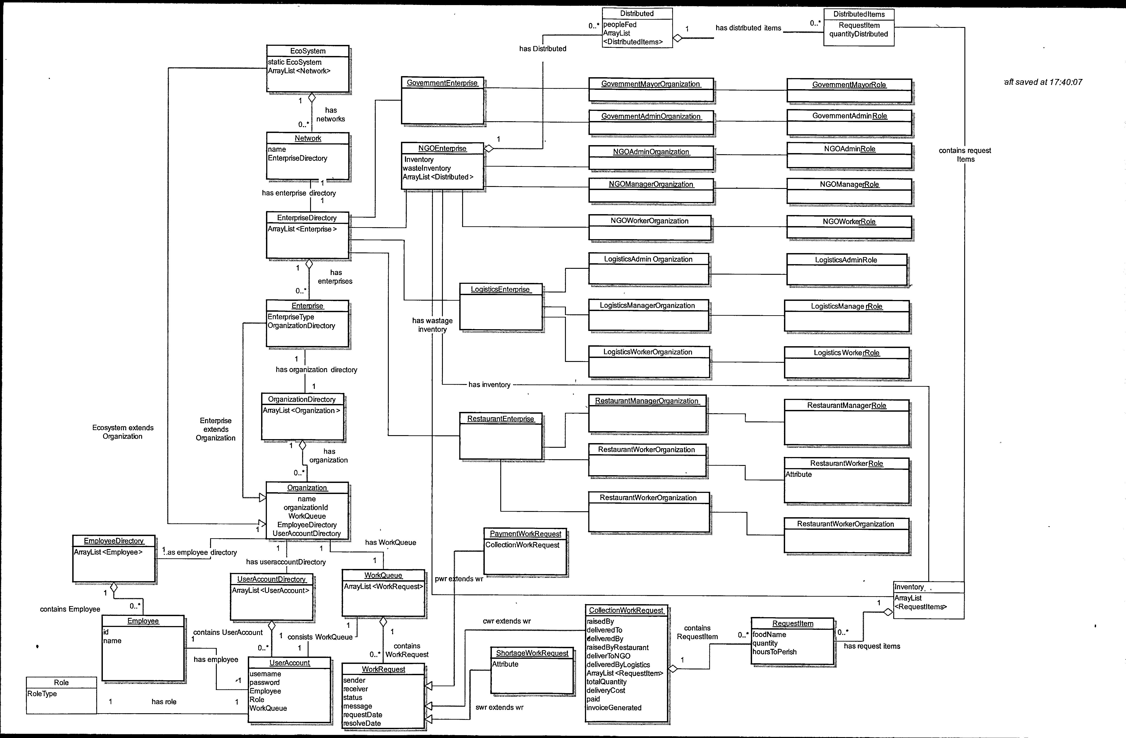
Object model
Some example images
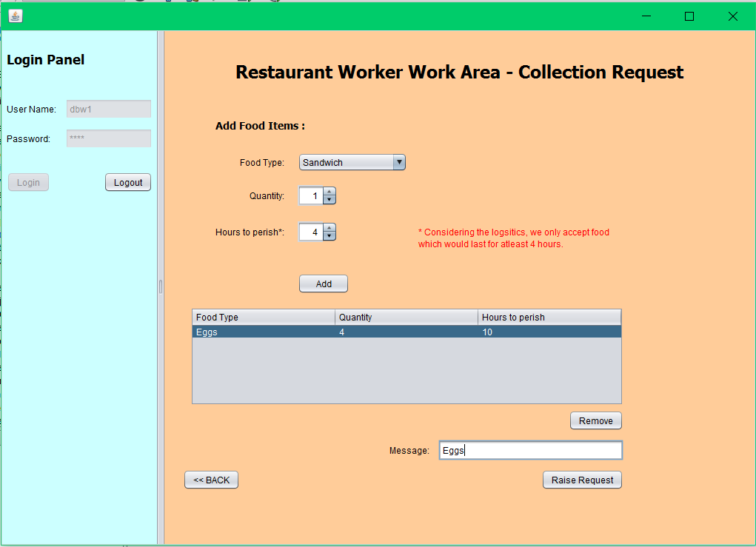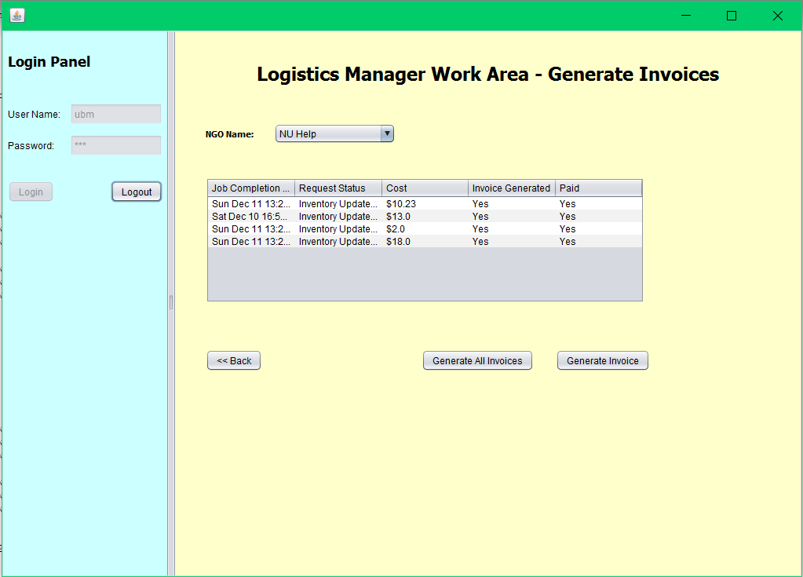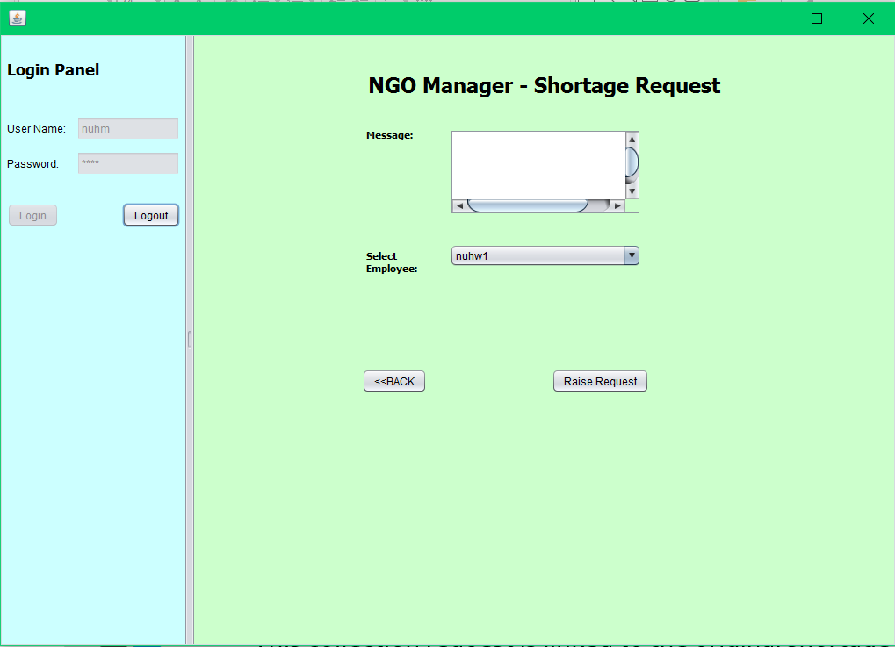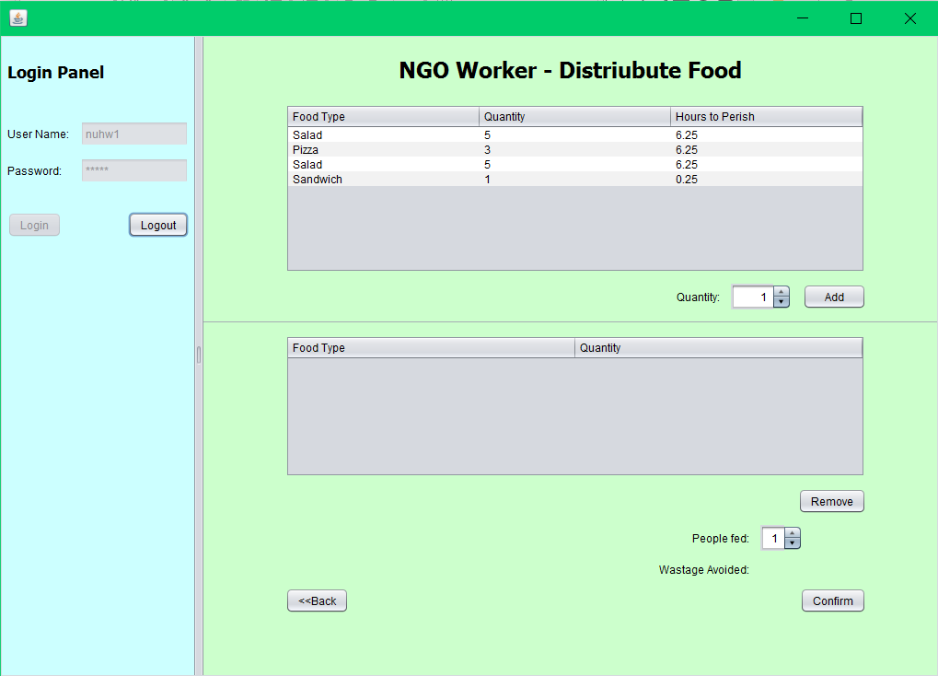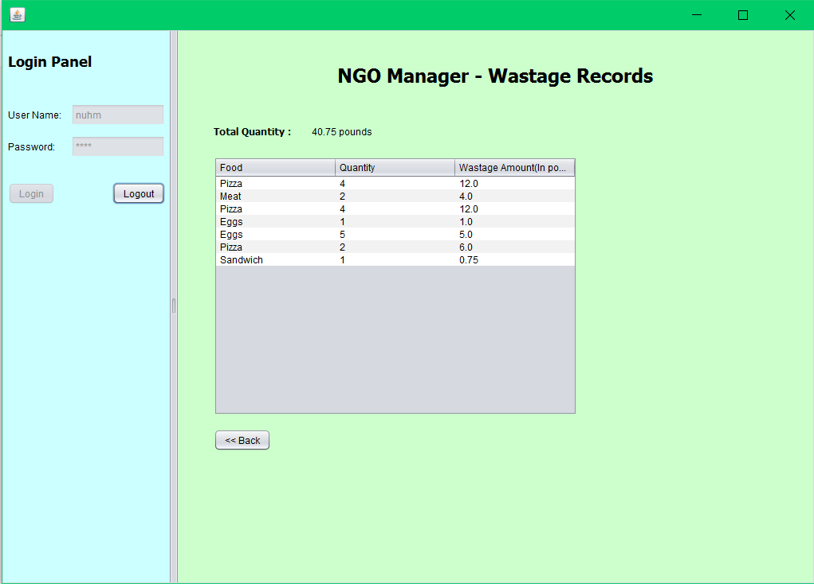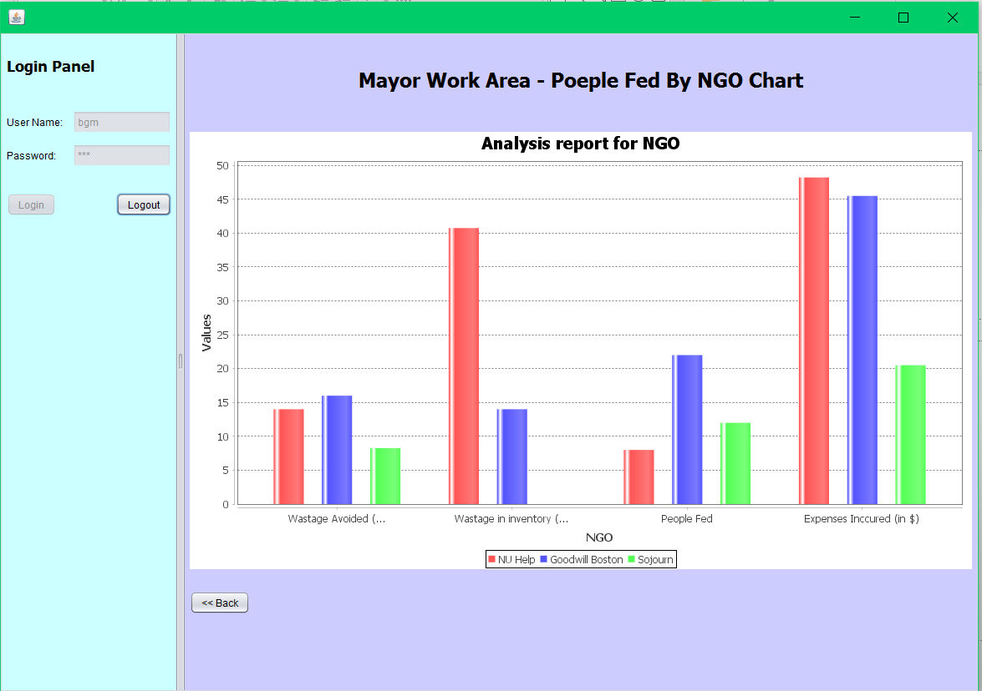

Future Scope
- Instead of just restaurants/cafés we can also have people register themselves
in the application to donate leftovers from parties/weddings
- Mayor can allocate funds to NGOs
- Ability to add non-perishable food. This can then
be sent across to other network in case of any
disasters resulting in shortage of food
- An ability of 1-1 tie-up between restaurant, NGO, and Logistics for pickups everyday

